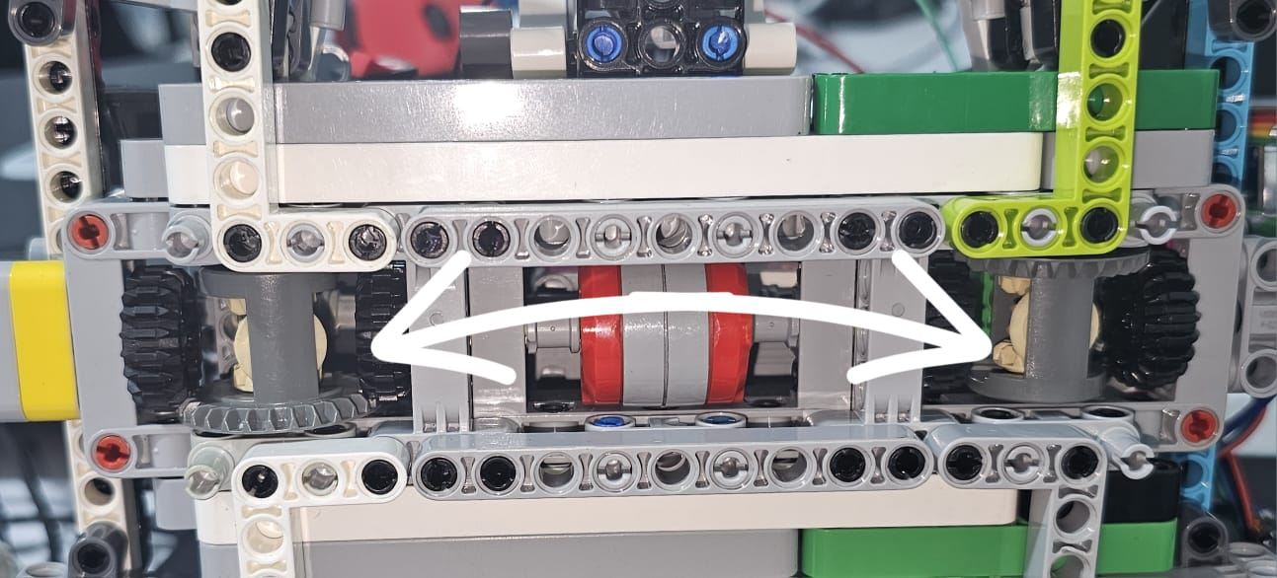

In mechanical engineering, differentials are used primarily to allow wheels on the same axle to rotate at different speeds . This is crucial for vehicles during turns, where the outer wheel travels a longer distance than the inner wheel. Without a differential, the wheel with less distance to cover would be forced to skid, causing handling issues and excessive tire wear.

